**Lab Report 2b- CSE 564: Visualization**

*- Ananna Rahman*

**Dataset** **Link**: <https://www.kaggle.com/datasets/sakshigoyal7/credit-card-customers>

**Dataset Attribute:**

Age: Represents the customer's age in years.

Gender: Represents the demographic variable, with 'M' denoting Male and 'F' denoting Female.

Dependent: Indicates the number of dependents each customer has. Although these are numerical values, they are treated as categorical due to their repetitive nature and limited range.

Education: Describes the educational qualification of the account holder (e.g., high school, college graduate, etc.).

Income: Represents the annual income category of the account holder, categorised as follows :Less than $40,000 ,$40,000 - $60,000, $60,000 - $80,000, $80,000 - $120,000, Greater than $120,000,Unknown

Months: Denotes the period of the customer's relationship with the bank.

Product: Refers to the total number of products held by the customer. Similar to dependents, this attribute is treated as categorical despite being numerical due to its limited and repetitive values.

Limit: Indicates the credit limit on the credit card.

Balance: Reflects the total revolving balance on the credit card.

Open-to-Buy : Represents the open-to-buy credit line for the last 12 months.

Change in Amount: Represents the total change in transaction amount (Q4 over Q1).

Transaction Amount: Denotes the total transaction amount for the last 12 months.

Transaction Count: Indicates the total transaction count for the last 12 months.Change in Change in Transaction Count: Reflects the change in transaction count (Q4 over Q1).

Utilisation Represents the average card utilisation ratio.

**Observation 1:**

The red dots are mostly in the upper right part of the chart, while the light blue dots are mainly in the lower left area. Dark blue dots, which are fewer, are spread out between the red and light blue dots, showing they might be a mix of the two main groups. The chart shows that red dots represent higher values and light blue dots represent lower values, with a gradual change from one to the other.

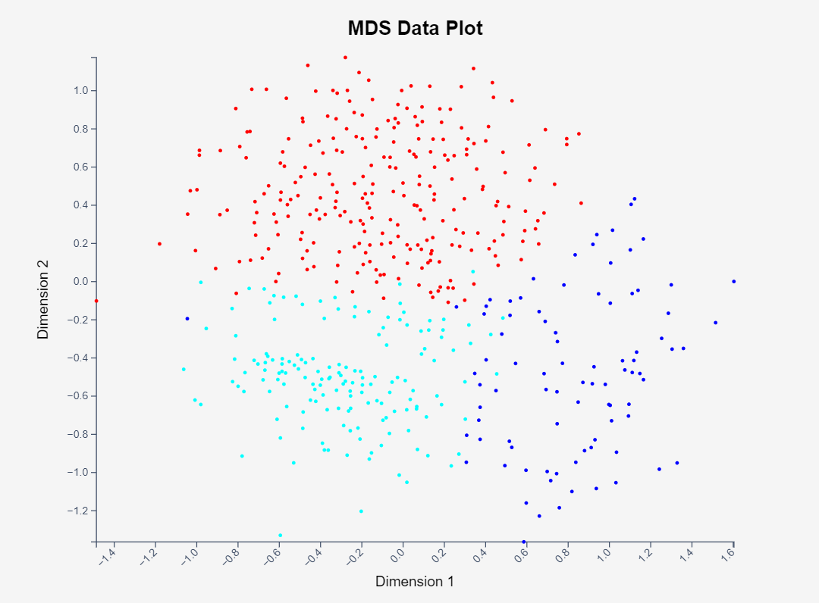

**Observation 2:**

.

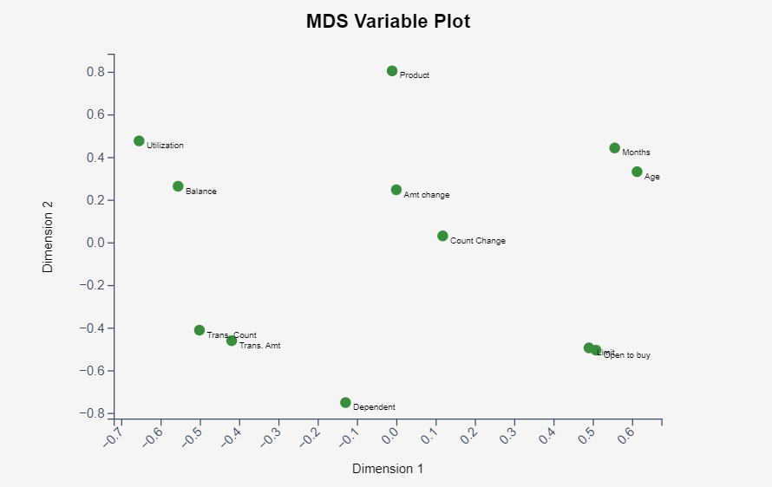

The MDS plot illustrates a number of inferred relationships between various financial variables.

There is a correlation between "Limit" and "Open to buy." This suggests that a higher credit limit is associated with an increased likelihood of getting new credit lines. When consumers have a higher credit limit, they may also have more unutilized credit available to them ("open to buy") .

A positive correlation is observed between "Utilization" and "Balance." This indicates that higher balances on credit accounts tend to lead to higher utilization rates. In practical terms as individuals carry larger balances on their credit cards, a greater proportion of their available credit is in use.

The variables "Total Transaction Amount" and "Transaction Count" are also correlated. This implies that as the number of transactions increases, so does the cumulative amount of those transactions. This relationship is intuitive since more frequent use of credit facilities typically results in a higher total spending amount.

An interesting and perhaps less expected correlation is found between "Relationship with the bank" and "Age." This could suggest that the length of a customer’s relationship with a bank is in some way connected to their age, which may reflect factors like customer loyalty or the accumulation of financial products and services over time.

**Observation 3:**

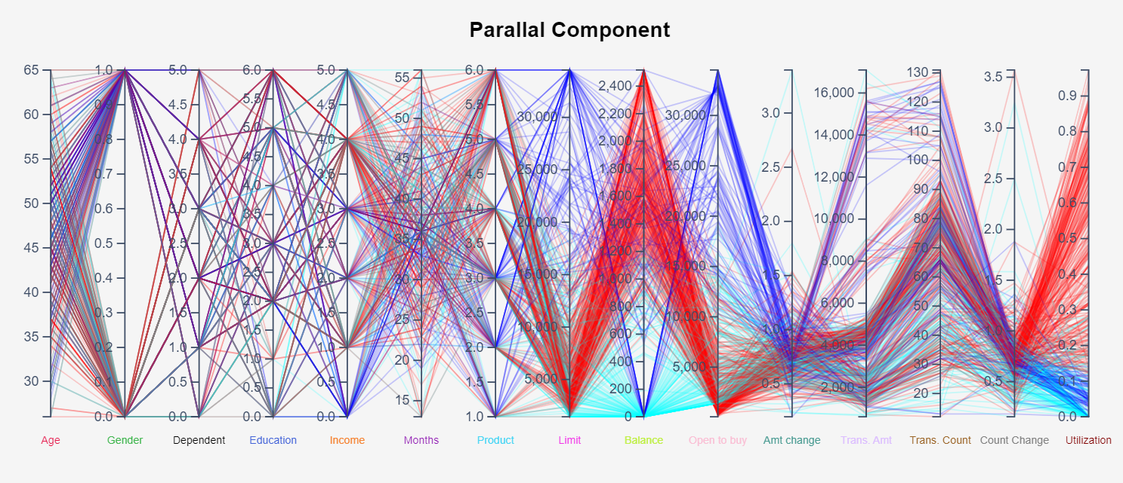

The parallel component analysis indicates a notable inverse relationship between credit limit and revolving balance — as the credit limit increases, the revolving balance tends to decrease, and the reverse is also observed. Gender appears to be distributed independently of age, showing a distinct and widespread pattern without a clear correlation to age. Additionally, education level does not exhibit a specific or discernible correlation with other factors under consideration.

**Running the application:**

To run the Angular project with D3.js charts, follow these steps:

1. Ensure you have Node.js version 16.14.2 and Angular version 12.2.17 installed on your system.

2. Navigate to the project directory using the terminal/command prompt. Run the following command to install all dependencies listed in the project's package.json file:

*npm install*

3. Once all dependencies are installed, start the development server by running the command:

*ng serve*

4. After the server has started successfully, open any web browser and go to the following URL:

[*http://localhost:4200/*](http://localhost:4200/)

**This will load the Angular application with the D3.js charts.**